Components
The code in this repository is implemented on an ESPVROOM 32 microcontroller.
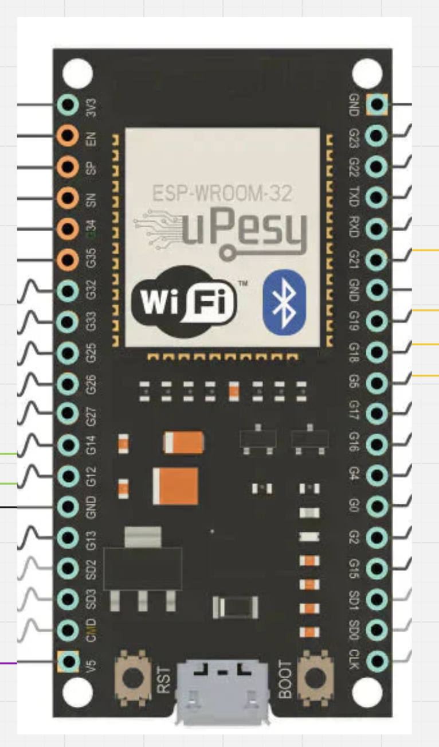
Figure 1ESPVROOM 32
It takes input from a FlySky FS-GR3E and controls a DF Robot motor controller.
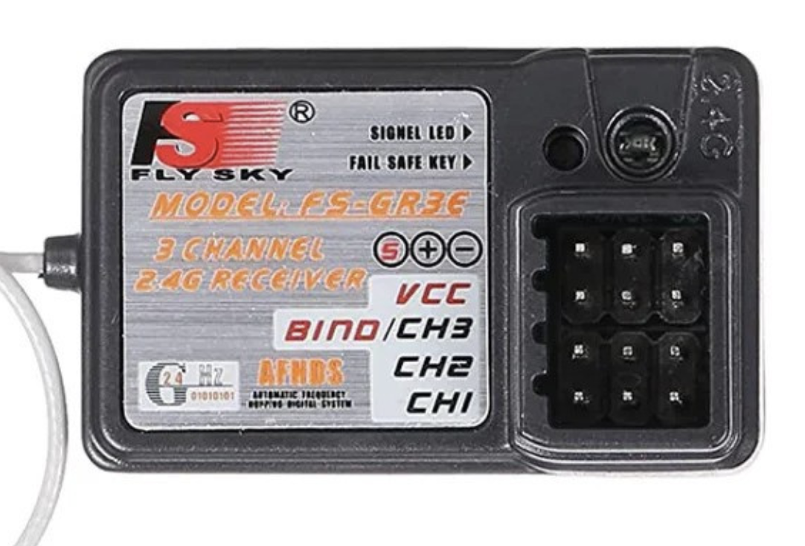  Figure 2FlySky FS-GR3E | 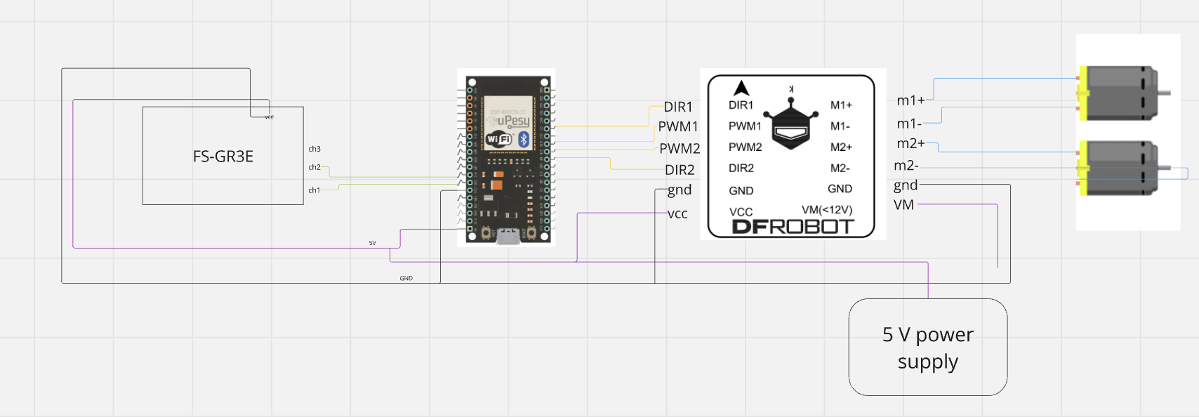  Figure 3Motor controller

HW design
The wiring is as follows:

Pinning information

ESP32 pin out
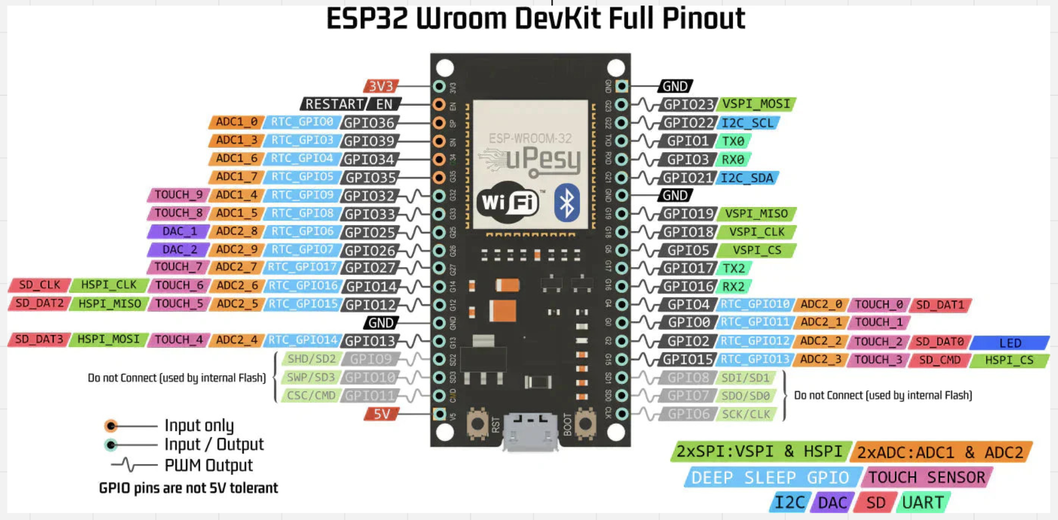

Aligning the pin-out for ESP32 to the FSIA 6B output
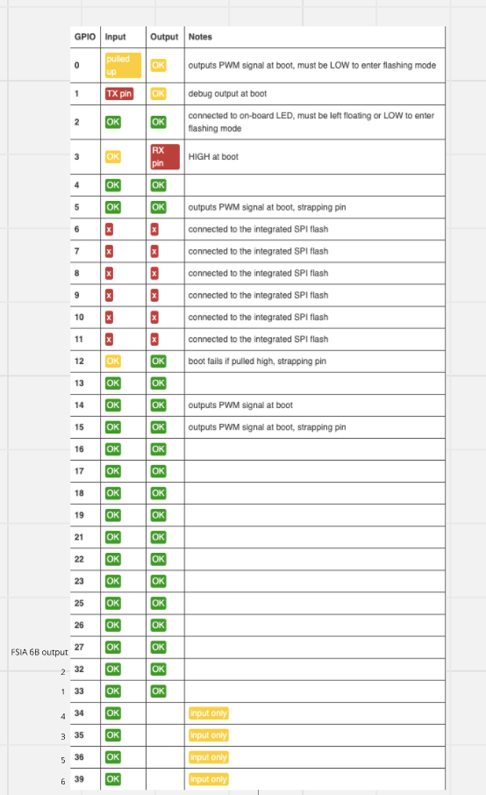

Aligning the pin-out for FSIA 6B to Aduino (The ESP32 are the same)
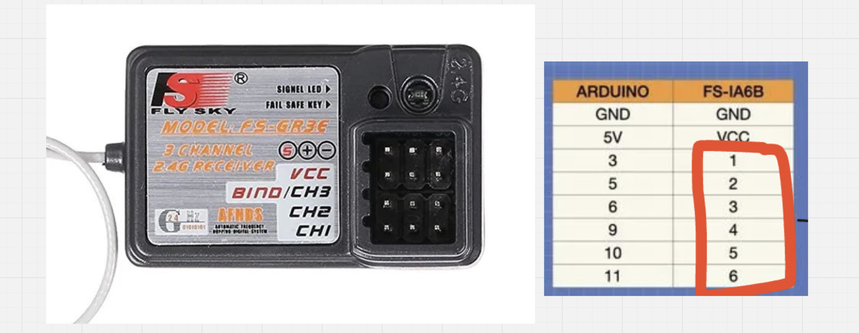

Aligning the pin-out for motor controler



